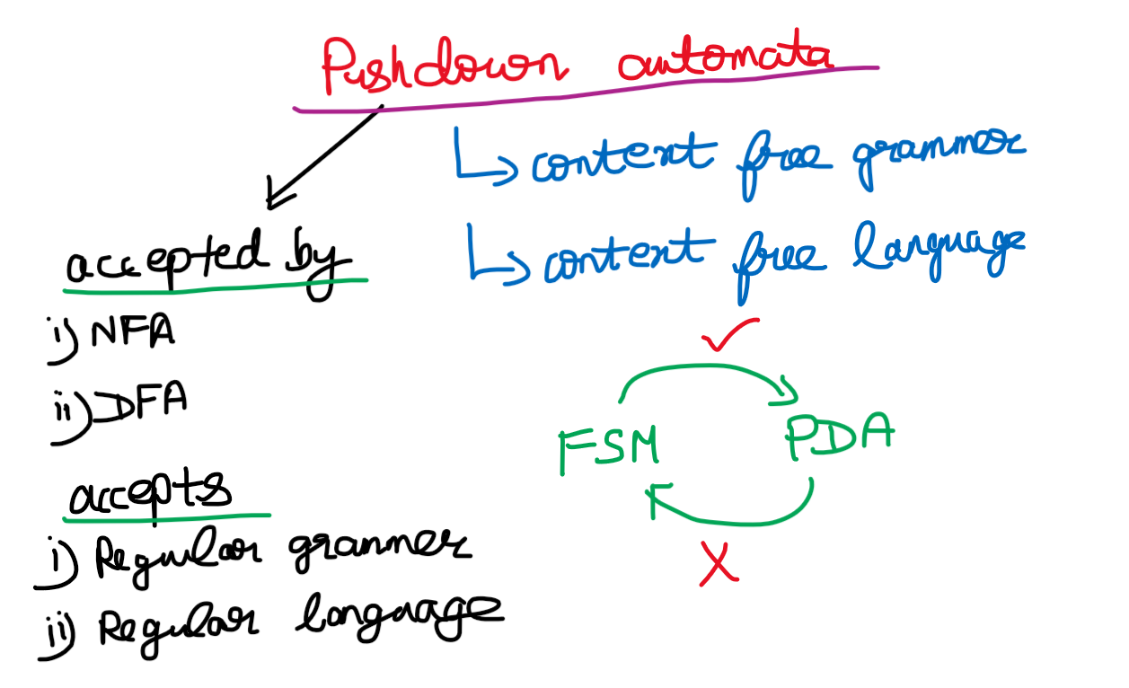

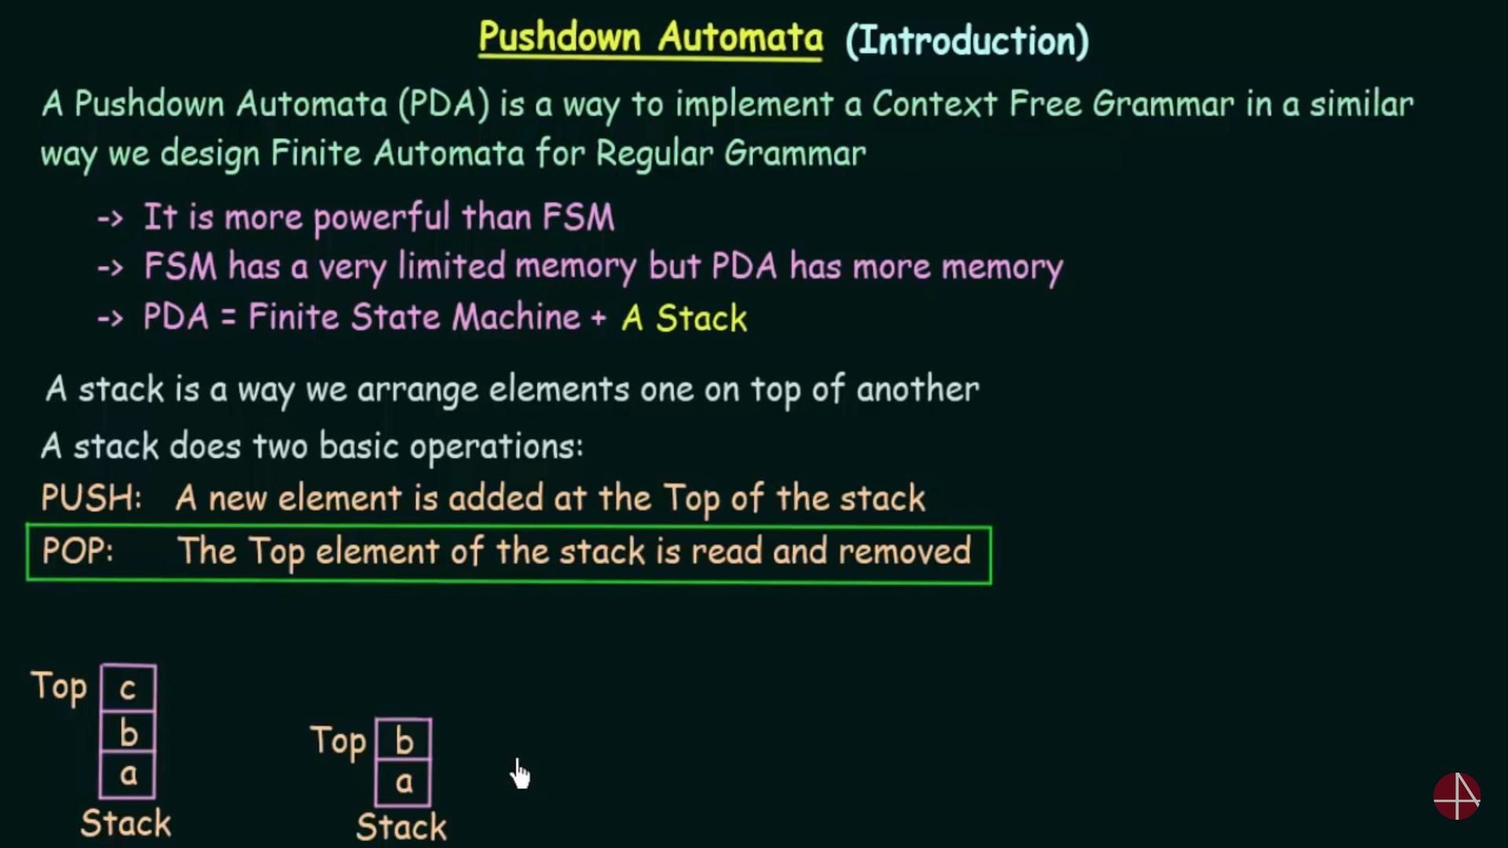

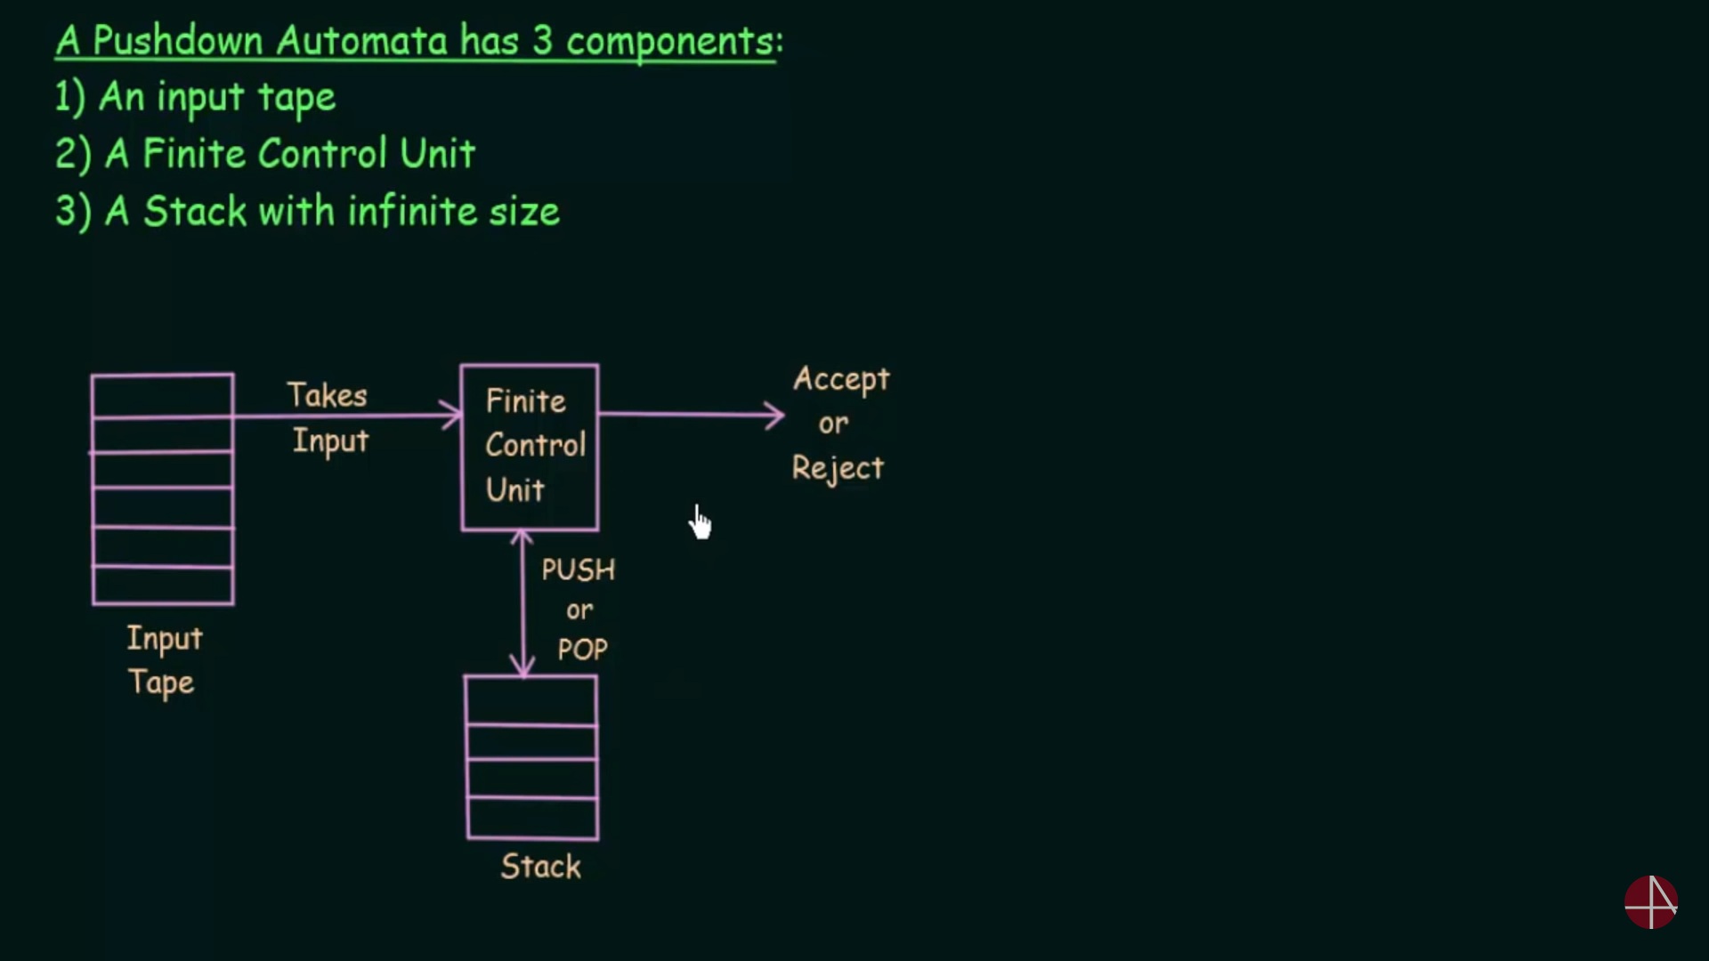

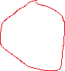

Finite automata F = (Q, $∑$,q0, ,F)



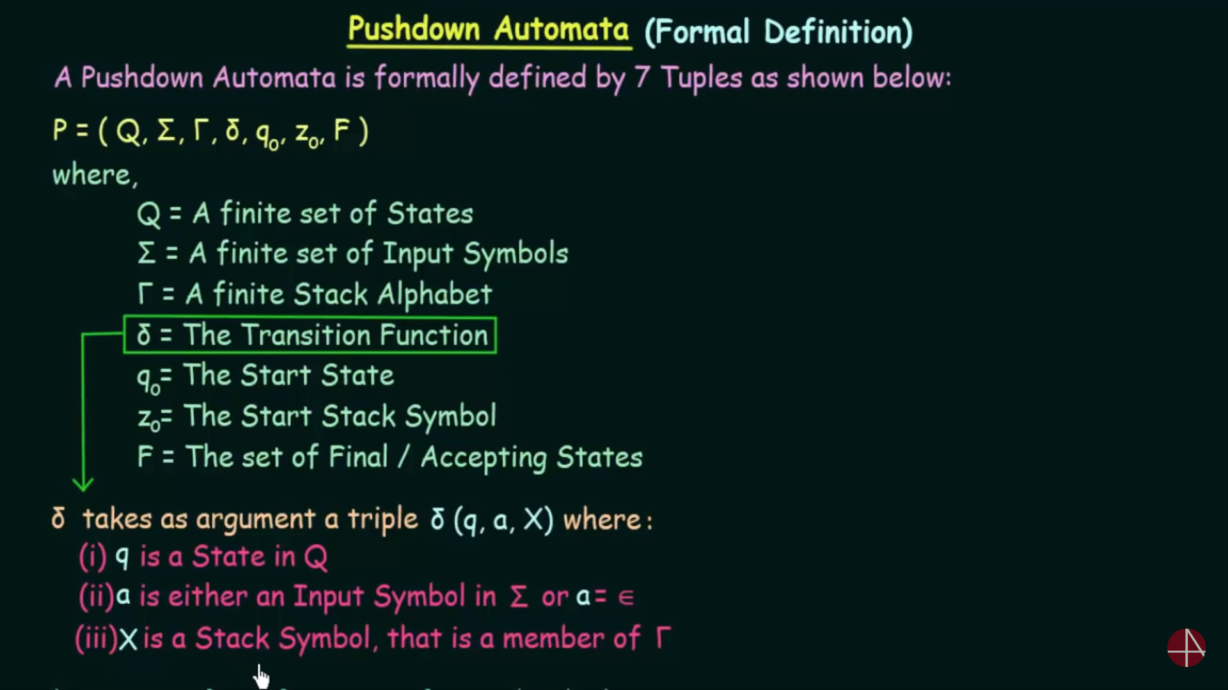



The transition function for finite automata is entirely different from push-down automata.

FA = (Q, $∑$)   
PDA = (Q1, $∑,$ Z0) 🡪 (Q2, V)



Q1 is one state and it is changed to Q2 which is another state.  
 🡪 one input alphabet   
Z0 🡪 top of the stack

(q1,a,b) 🡪 (q2,epsilon)   
[a 🡪 input symbol(cursor) and b 🡪 top of the stack]  
If V 🡪 epsilon (Whenever the stack’s top and the cursor symbol are different they are cancelled eachother.



(q1,a,z) 🡪 (q2,az)   
If V 🡪 az (Whenever the stack is empty (i.e denoted by z) and the cursor symbol is about to enter into the stack.



(q1,a,a) 🡪 (q2,aa)  
If V 🡪 aa (Whenever the top of the stack and the cursor symbol are same then that cursor symbol will be added to the stack instead of cancelling.



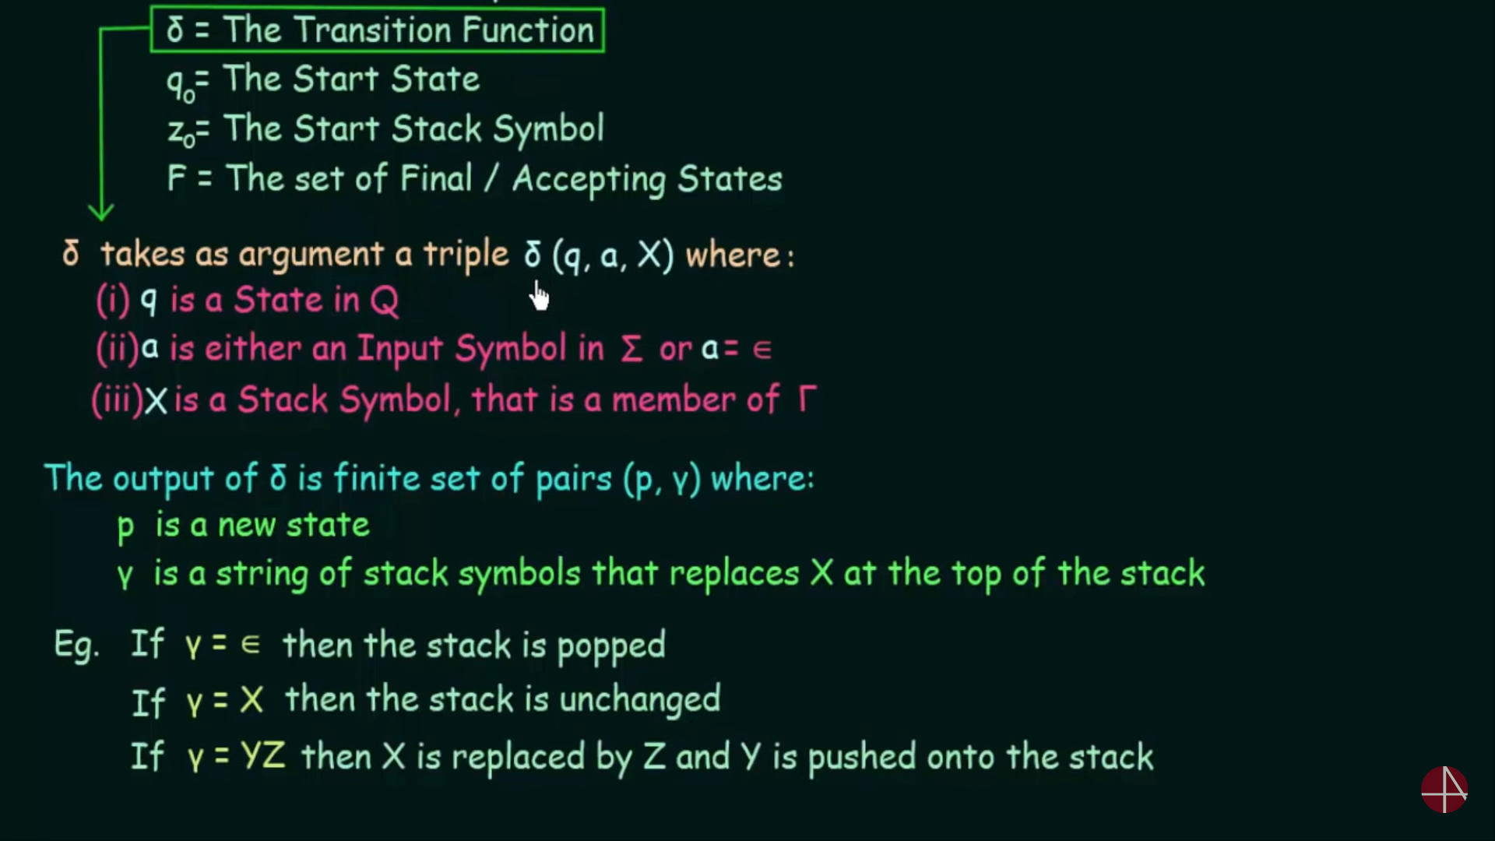

**Instantaneous Description**

**Instantaneous Description** (ID) is an informal notation of how a **PDA** “computes” a input string and make a decision that string is accepted or rejected.

